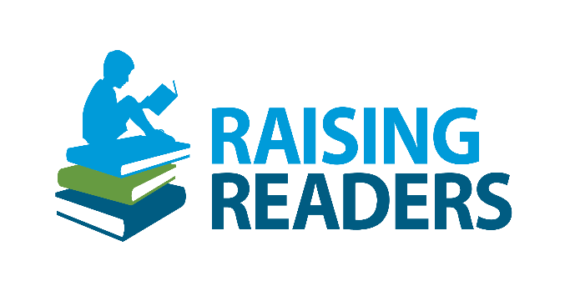**Media release templates for 2023 national fraternal campaign activities**

*Customize the applicable media release below with your activity details where indicated. To send to your local media outlets, copy and paste your media release text into the body of an email, then send to a local newsroom, reporter and/or editor.*

**[General media release]:** To use for any 2023 national campaign activity.

**Modern Woodmen members participate in Raising Readers campaign**

*Activity promotes children’s literacy in local community*

Local Modern Woodmen of America members are taking action to promote children’s literacy in the [city/state] community.

Modern Woodmen’s Raising Readers campaign is a nationwide initiative focusing on different ways to promote children’s literacy in the community each quarter. The first quarter focuses on members reading to or with children; the second quarter brings members together to gather children’s books and place them in the community; the third quarter encourages members to adopt a classroom, library or children’s organization to donate supplies to; and the fourth quarter has members creating homemade children’s books.

[Describe activity in 1-3 sentences: could include date(s) of event, person(s) recognized, location(s), and additional details.]

**About Modern Woodmen**

Modern Woodmen was founded in 1883 as a fraternal benefit society. The organization supports members, families and communities with a unique blend of financial services, fraternal benefits and local-impact opportunities. Each year, Modern Woodmen and its members provided millions of dollars and thousands of volunteer hours to support fraternal activities and programs. Learn more at [www.modernwoodmen.org](http://www.modernwoodmen.org).

**[Quarter 4 media release]:** To send during or after Quarter 4 – Service project, educational event OR Hometown Hero: Tell me a Story

**Modern Woodmen members help children tell their story**

*Activity promotes children’s literacy in local community*

Local Modern Woodmen of America members are taking action to promote children’s literacy in the [city/state] community by helping children create their own stories in homemade children’s books.

[Describe activity in 1-3 sentences: could include date(s) of event, materials used, groups partnered with, and additional details.]

Modern Woodmen members came together to create homemade children’s books in support of the organization’s nationwide initiative focusing on different ways to promote children’s literacy in the community each quarter. The first quarter focused on members reading to or with children; the second quarter brought members together to gather children’s books and place them in the community; the third quarter encouraged members to adopt a classroom, library or children’s organization to donate supplies to; and the fourth quarter has members creating homemade children’s books.

**About Modern Woodmen**

Modern Woodmen was founded in 1883 as a fraternal benefit society. The organization supports members, families and communities with a unique blend of financial services, fraternal benefits and local-impact opportunities. Each year, Modern Woodmen and its members provided millions of dollars and thousands of volunteer hours to support fraternal activities and programs. Learn more at [www.modernwoodmen.org](http://www.modernwoodmen.org)